**OPERATING SYSTEM LAB 4**

S ABHISHEK

AM.EN.U4CSE19147

**1. Write a shell script to generate emails in the given format and write it into a file. Your script should accept sender and recipient email id’s and subject as command line arguments.**

**From: abc@domain1.com To: xx@domain.com Cc: yy@domain.com**

**Subject: Subject 1**

**This email is generated by my shell script.**

**Thanks and regards**

**S4 CSE student**

**Amritapuri**

#!/bin/bash

echo -e "\nFrom : $1 To : $2 cc : abc@domain.com"

echo -e "\nSubject : $3"

echo -e "\n This email is generated by my shell script."

echo -e "\nThanks and regards"

echo "S4 CSE student"

echo -e "Amritapuri\n"

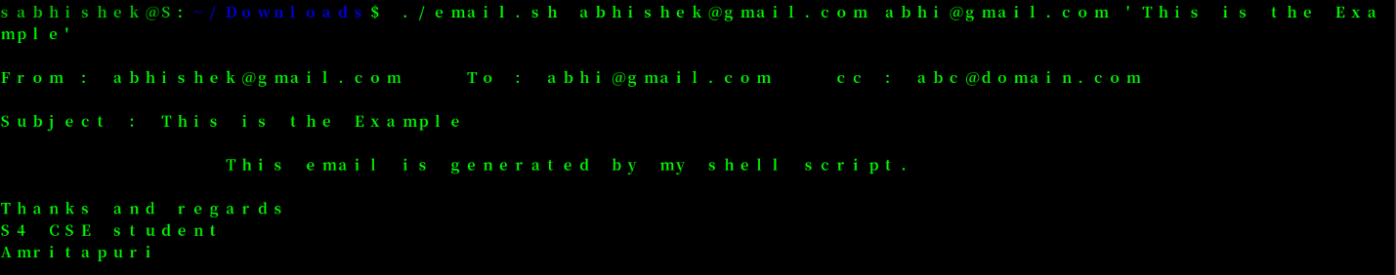

**2. Modify Question 1 to allow user to enter text at the beginning of email content, by passing it as a command line argument.**

#!/bin/bash

echo -e "\n$1"

echo -e "\nFrom : $2 To : $3 cc : abc@domain.com"

echo -e "\nSubject : $4"

echo -e "\n This email is generated by my shell script."

echo -e "\nThanks and regards"

echo "S4 CSE student"

echo -e "Amritapuri\n"

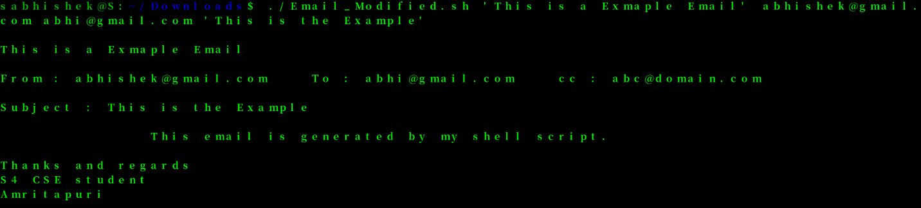

**3. Write a shell script to print all the primes below a given number.**

#!/bin/bash

prime()

{

for ((i=2; i<=$1; i++ ))

do

f=0

if [ $i -lt 1 ]

then

continue

fi

for ((j=2; j<$i; j++ ))

do

if [ $(($i % $j)) == 0 ]

then

f=1

break

fi

done

if [ $f -eq 0 ]

then

echo -n -e "$i "

fi

done

echo ""

}

prime $1

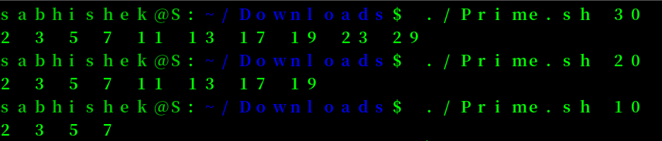

**4. Write a shell script to print the first n Fibonacci numbers.**

#!/bin/bash

fibonacci()

{

s1=0

s2=1

s3=0

echo -n -e "Fibonnaci Series : "

for (( i=1;i <= $1;i++))

do

echo -n -e "$s1 "

s3=$((s1+s2))

s1=$s2

s2=$s3

done

echo ""

}

fibonacci $1



**5. Write a shell script to generate a multiplication table.**

**a. Interactive version: The program should accept an integer n given by the user and should print the multiplication table of that n.**

**b. Command line arguments version: The program should take the value of n from the arguments followed by the command.**

**c. Redirection version: The value of n must be taken from a file using input redirection.**

#!/bin/bash

table()

{

for((i=1;i<=$1;i++))

do

echo "$i * $1 = $((i*$1))"

done

}

read -p "Enter the Number : " num

table $num

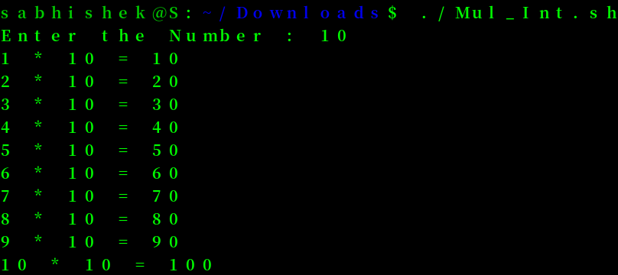

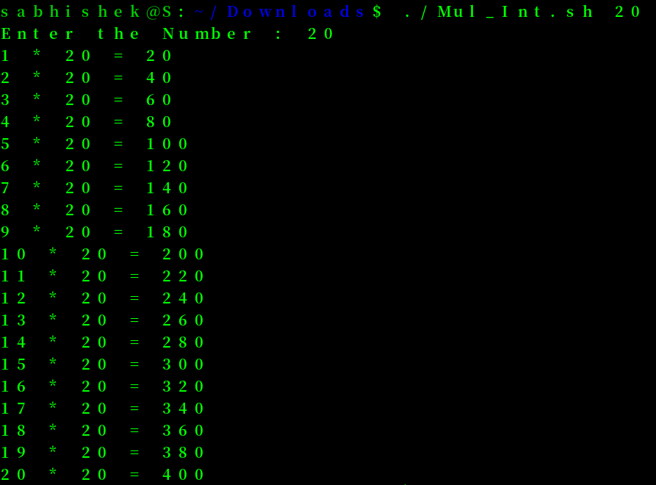

#!/bin/bash

table()

{

for((i=1;i<=$1;i++))

do

echo "$i * $1 = $((i*$1))"

done

}

table $1

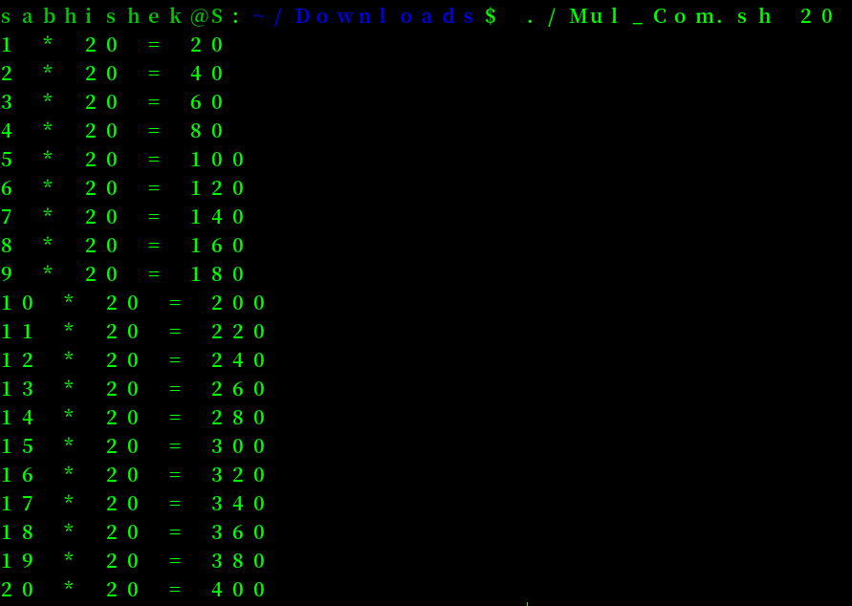

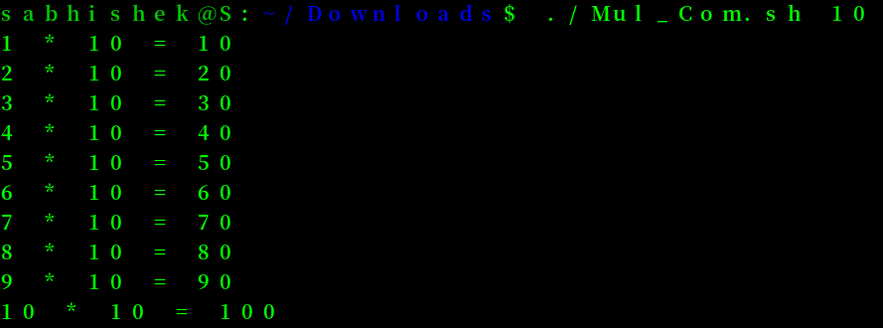

#!/bin/bash

table()

{

for((i=1;i<=$1;i++))

do

echo "$i * $1 = $((i*$1))"

done

}

read num

table $num

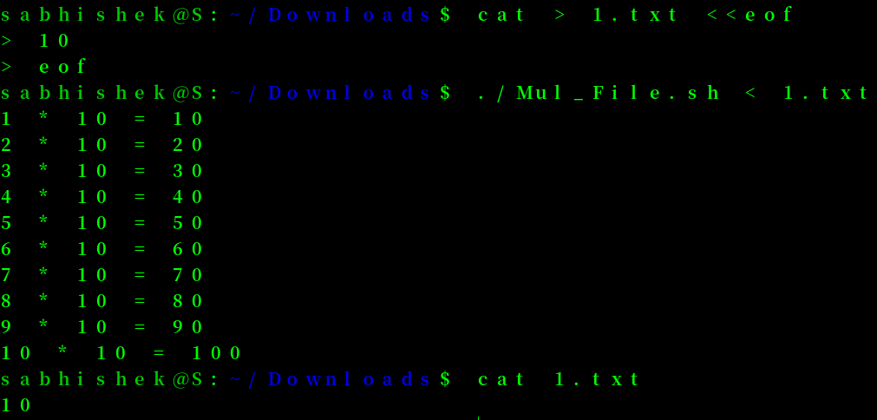

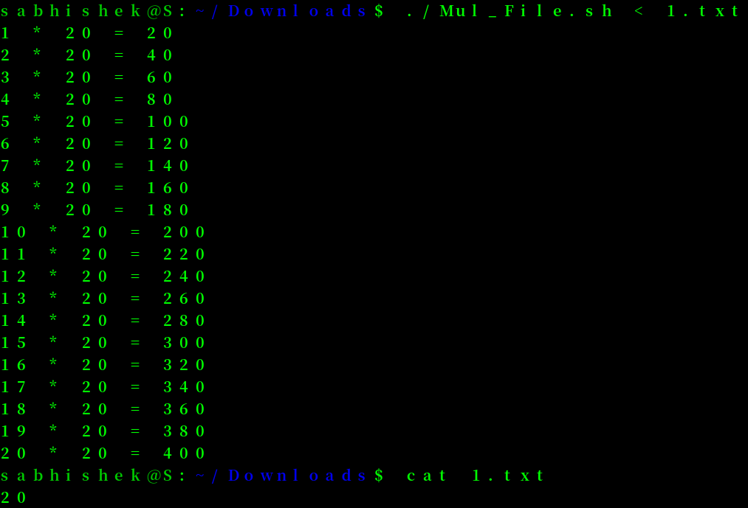

**6. Using function write a shell script to find gcd of two numbers.**

#!/bin/bash

gcd()

{

gcd=0

for((i=1;i<=$1 && i<=$2;i++))

do

if [ $(($1 % i)) == 0 ]

then

if [ $(($2 % i)) == 0 ]

then

gcd=$i

fi

fi

done

echo "GCD = $gcd"

}

gcd $1 $2

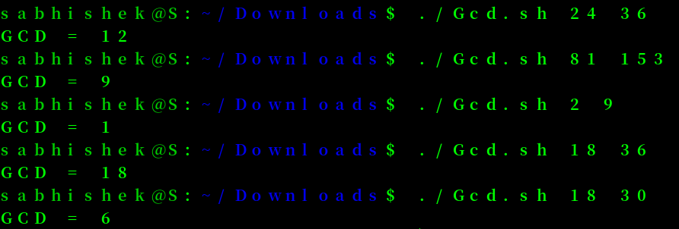

**7. Using Recursion find factorial of a number**

#!/bin/bash

factorial()

{

if (( $1 <= 1 ))

then

echo 1

else

echo $(( $1 * $(factorial $(( $1 - 1 )))))

fi

}

factorial $1

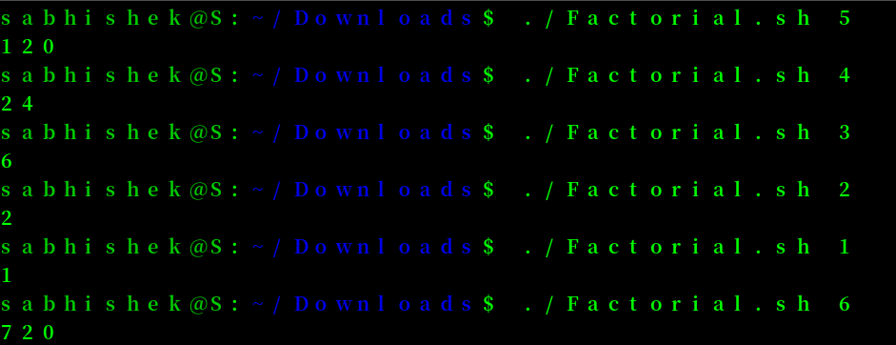

**8. Write shell script to show various system configuration like:**

**a. Currently logged user and his long name**

**b. Current shell**

**c. Home directory**

**d. Operating system type**

**e. Current path setting**

**f. Current working directory**

**g. All available shells**

#!/bin/bash

echo ""

echo "############### Currently logged user ###############"

whoami

echo ""

echo "############### Current shell ###############"

echo "$SHELL"

echo ""

echo "############### Home Directory ###############"

cd ~ | ls

echo ""

echo "############### Operating system type ###############"

egrep '^(VERSION|NAME)=' /etc/os-release

echo ""

echo "############### Current path setting ###############"

echo $PATH

echo ""

echo "############### Current working directory ###############"

pwd

echo ""

echo "############### All available shells ###############"

cat /etc/shells

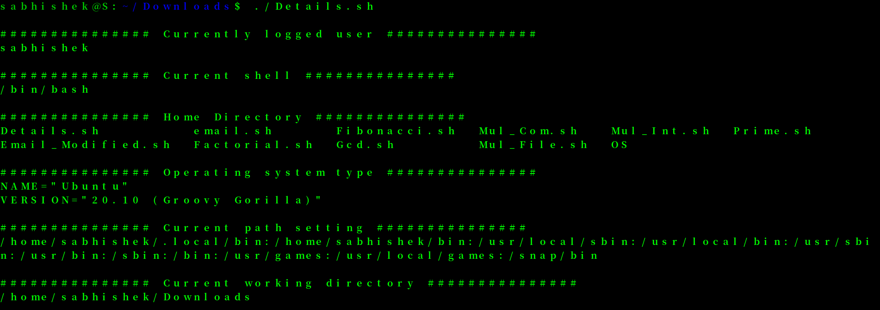

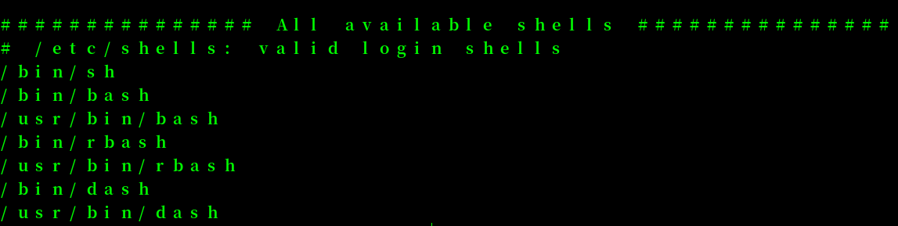

**Thankyou!!**